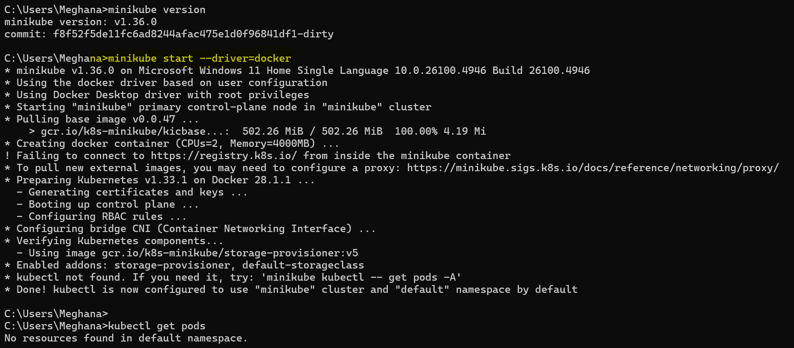

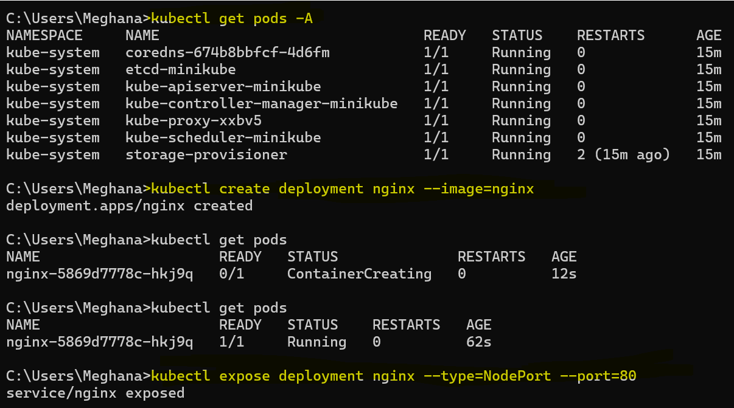

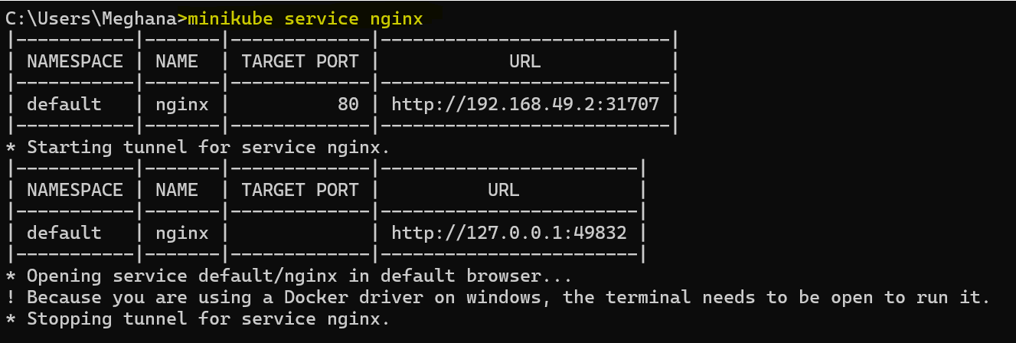

NGINX welcome page.

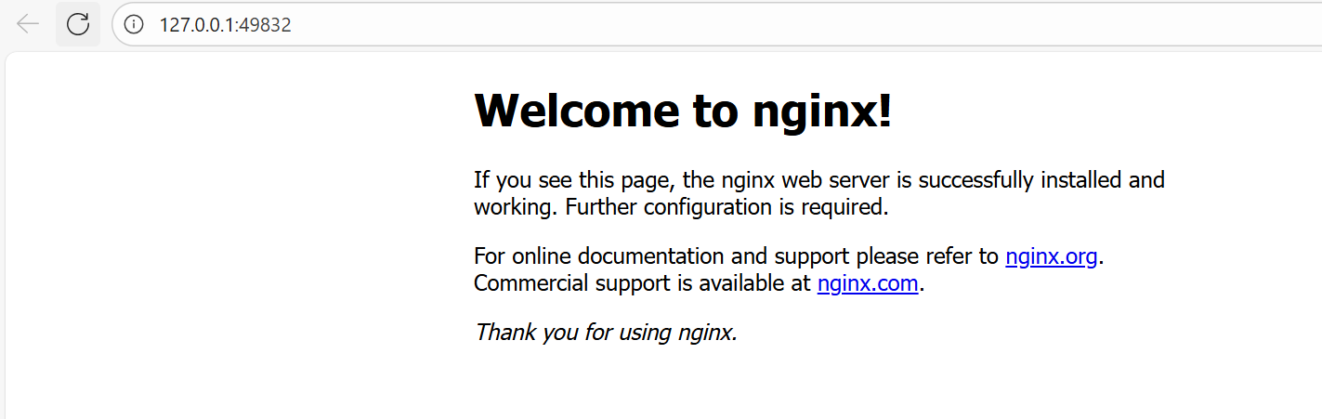

Scaling:

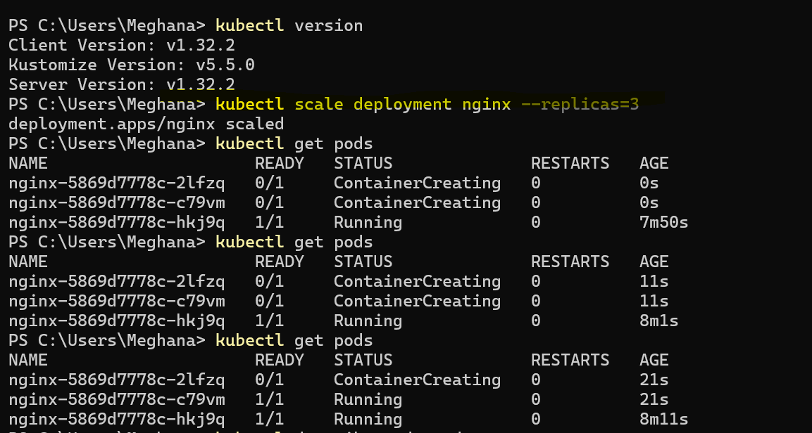

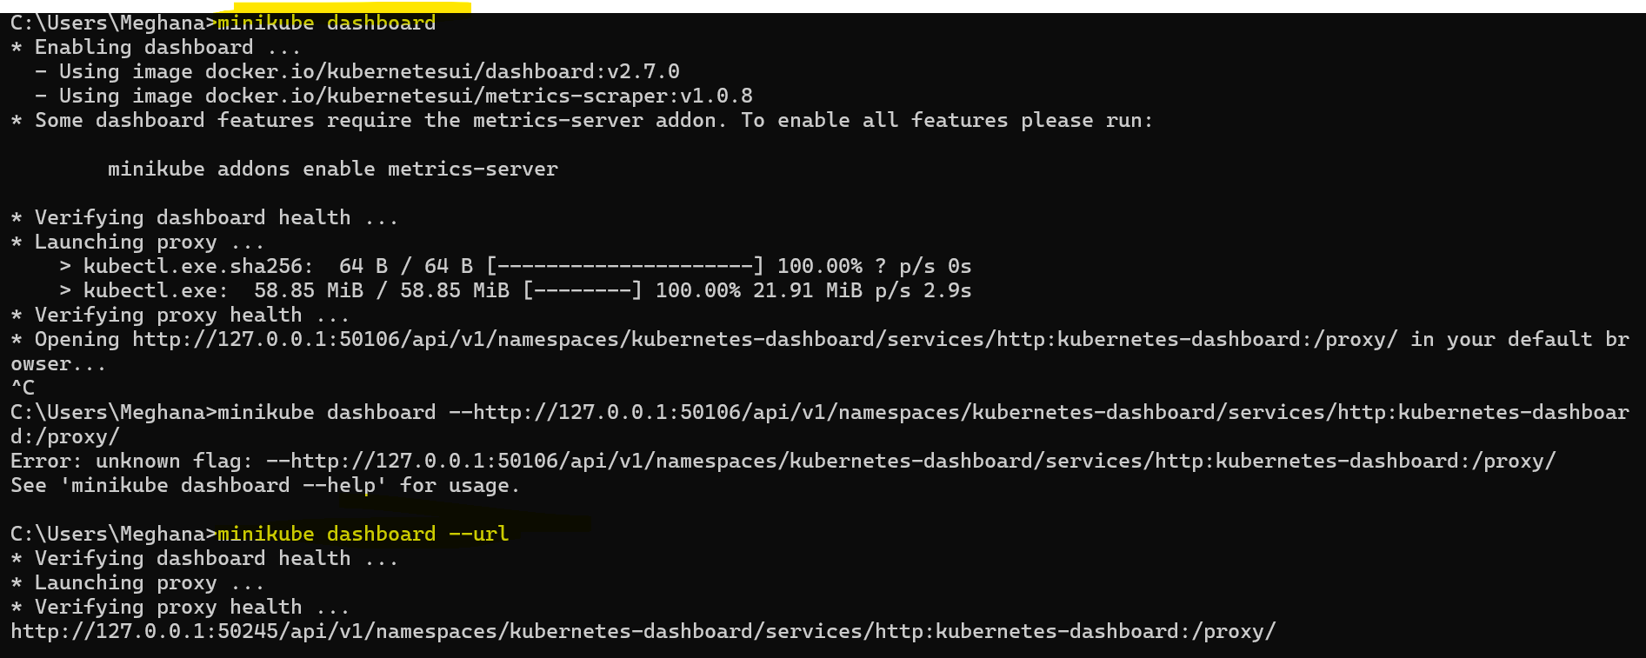

Kube dashboard url :

[Kubernetes Dashboard](http://127.0.0.1:50106/api/v1/namespaces/kubernetes-dashboard/services/http:kubernetes-dashboard:/proxy/#/workloads?namespace=default)

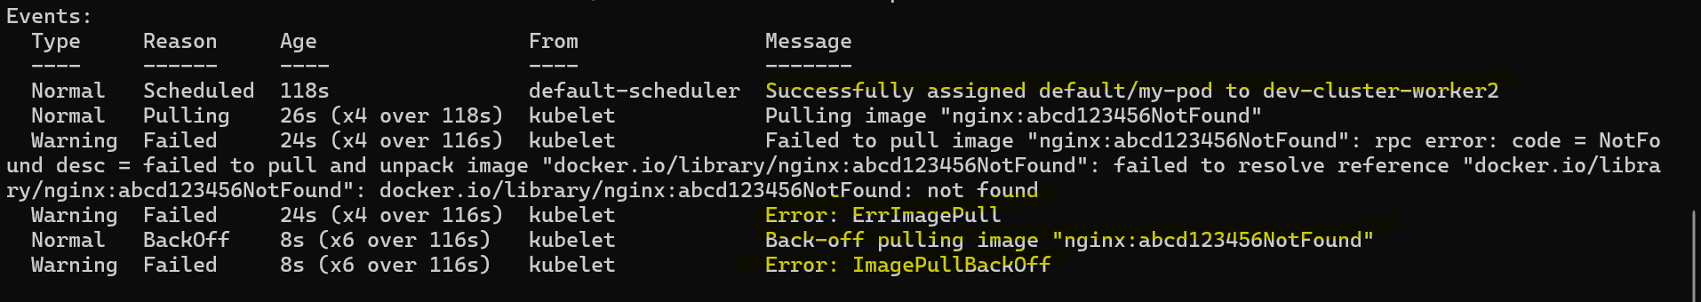

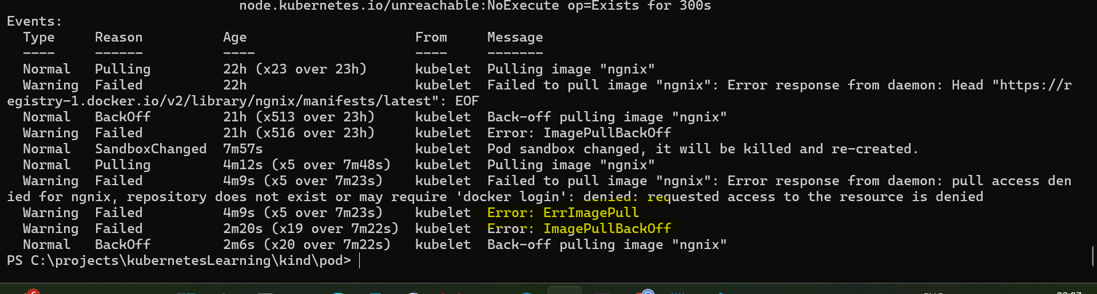

**CrashLoopBackOff**

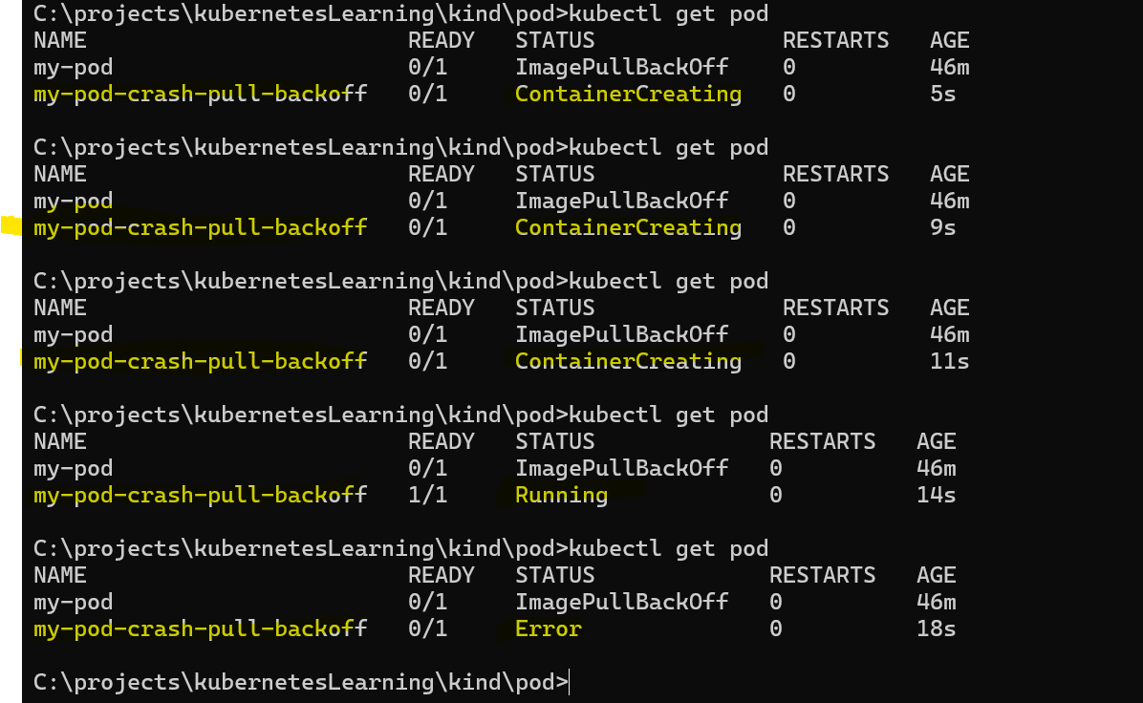

**Port-Forward:**

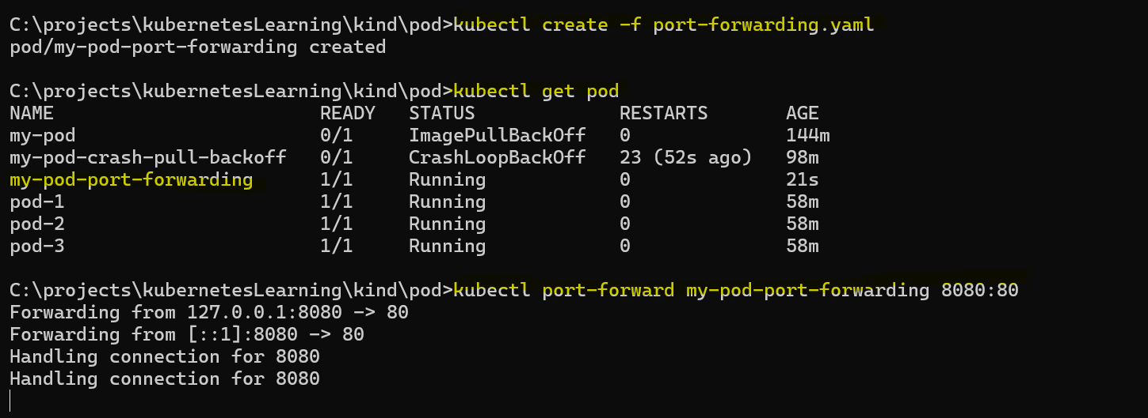

**launch the localhost browser** <http://localhost:8080/>

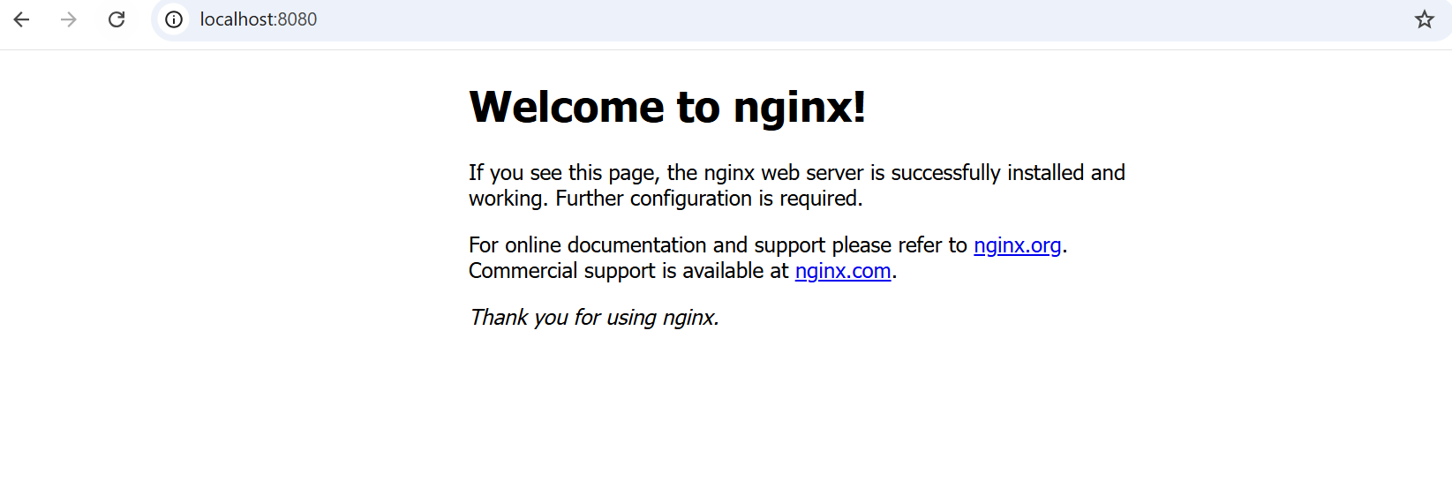

Pod-args

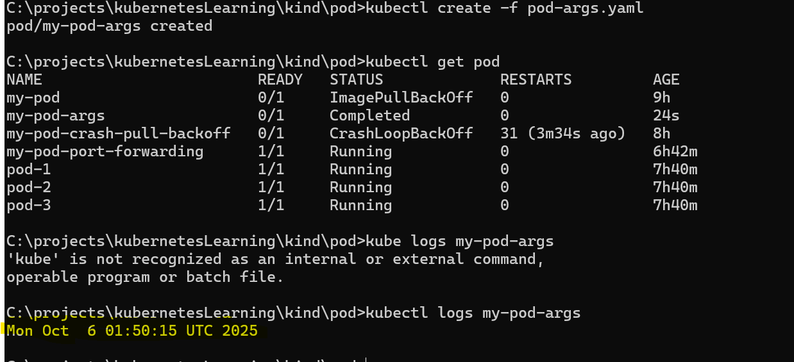

Pod-shell-args

